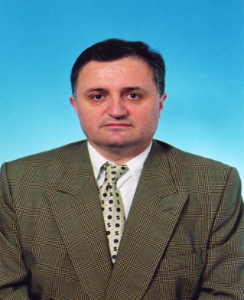

Prof. Dr. Vidosav MAJSTOROVIC, Belgrade University, Mechanical Engineering Faculty, Belgrade, Serbia.

