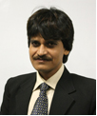

Dr.Muhammad Imtiaz Subhani

